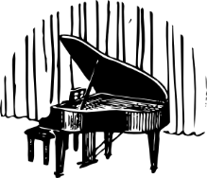 | Recital Video Evaluations  2015 Winter Studio Recital  December 19, 2015 | 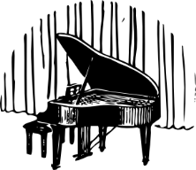

Name: Piece Performed:

The 3 things I liked about my performance:

1.

2.

3.

List 1, 2 or 3 things that you wish to improve on your performance.

1.

2.

3.

Check here if you are completely satisfied with your performance.

Watch at least 3 other performances and list what you liked best about that performance.

1. Name: Piece Performed:

What I liked best was

2. Name: Piece Performed:

What I liked best was

3. Name: Piece Performed:

What I liked best was
Here are more performances I watched!

4. Name: Piece Performed:

What I liked best was

5. Name: Piece Performed:

What I liked best was

6. Name: Piece Performed:

What I liked best was

7. Name: Piece Performed:

What I liked best was

8. Name: Piece Performed:

What I liked best was

9. Name: Piece Performed:

What I liked best was

